Contents
1. Project Management 3
1.1 Journal - Steps Taken to Complete the Project 3
1.2 Project Plan – Gantt Chart 5
2. Defining the Problem 6
1.1 Problem Statement 6
1.2 Objective 7
1.3 Scope 7
1.4 Boundary / Out of Scope 8
1.5 Functionality 9
1.6 Feasibility 10
2 Plan the Solution 11
2.1 Context Diagram 11
2.2 Level 1 Data Flow Diagram 12
2.3 System Flow Chart (One Process – Registration) 12
2.4 Structure Chart 13
2.5 IPO Chart 14
2.6 Data Dictionary 18
2.7 Storyboards 21
3 Test the Solution 23
3.1 Test Journal 23
4 Ongoing / Evaluation 26
4.1 Evaluate Software Development Approach 26
4.2 What if there were any changes in the development steps after customer and peer feedback 26
4.3 Give reasons if your deadline and scope has changed in any way this includes any changes of the number of man hours calculated in your Gantt Chart? 26
5 Submission 27
5.1 User Manual 27
5.1.1 About the User Manual 27
5.1.2 Synopsis 27
5.1.3 Minimum Specifications (Software and Hardware): 28
5.1.4 Setup Application 30
5.1.5 How to Use Mypharmabank 33
5.1.6 Troubleshooting 46
5.1.7 Frequently asked questions 47
6 References 48

Project Management

Journal - Steps Taken to Complete the Project

Date | Arjun Hariharasuthan
 | ARJUN HARIHARASUTHAN: ALL WORK DONE:
03- Apr-2023 | I had discussed with Mr. Phua, our project manager the various ideas about this project initiative. The proposed initial idea was to create an APP to connect all Pharmacists and Patients in one place for the appointment. I understood that apps like these exist in the real world already, hence I took my time to develop other ideas for this project.
07- Apr-2023 | I had proposed another idea that would create an online platform to connect all pharmacy providers in one place to manage the drug demand from various patients, display stock availability in the App and establish an online communication mechanism between patient and pharmacy to secure the drugs. Mr. Phua had welcomed my idea and encouraged me to come up with a Problem Statement document.
26- Apr-2023 | By this point, I had shared the Problem Statement, and received the comments from Mr Phua to include the feasibility study. I had incorporated.
28- Apr-2023 | I have used Python programming in the past and interested in exploring further . Hence, I have chosen Python Tkinter GUI and SQLite as a data base
2-May-2023 | I have faced little challenges in converting my ideas of the project to Structure chart. I have read the book “Software Design and Development by Samuel Davis” and saw some examples. It really helped to complete my tasks.
12 -May-2023 | I have completed my draft version of all design diagrams / charts as part of Define and Understand the problem. The diagrams include System chart, Context diagram, DFD, Structure Charts, IPO charts, Data Dictionary and Storyboards.
24-May-2023 | Mr Phua prefers to review the Context Diagram and DFD before starting the rest of them. We had a good discussion and understood his review comments for those documents. Great Learning.
29-May-2023 | The Login Screen module development is completed with testing. I can see the OTP creation, the email sent to users registered email. Therefore, the verification part is successful.
5-Jun-2023 | I have incorporated the review comments in context diagrams and DFD. I have also slightly modified the System chart and Structure Charts to align with the context diagram & DFD changes made and submitted to Mr. Phua for review.
6-Jun-2023 | The process can display the search results after the user inputted in the Search Screen module. I still need to do some more testing.
7-Jun-2023 | I have updated System chart and Structure Charts and delivered to Mr. Phua for review.
15-Jun-2023 | I have received comments from Mr. Phua for System chart and Structure Charts have been delivered to Mr. Phua for review. Comments mainly on Sequencing of structure charts that requires some alignment.
22-Jun-2023 | Made some updates in IPO chart to align with changes / comments received from Mr. Phua for the Structure chart. Also, the Data dictionary has been shared.
22-Jun-2023 | Completed the Development with End-to-End Testing. I have started the preparing the User guide.
22-Jun-2023 | I had a personal meeting with Mr.Phua on a voice call for his final feedback. I have shared my screen to view my program and ran through it for him. He gave me feedback on the GUI looks, such as the colour, buttons. On this very day, after his call I implemented all his feedback in my program.
23-Jun-2023 | User guide is also completed. Also, the project plan is updated with status for the tasks.
23-Jun-2023 | I have completed building component packaging.
23-Jun-2023 | All documents integrated as one document along with the scripts package have been uploaded to google classroom.

Project Plan – Gantt Chart

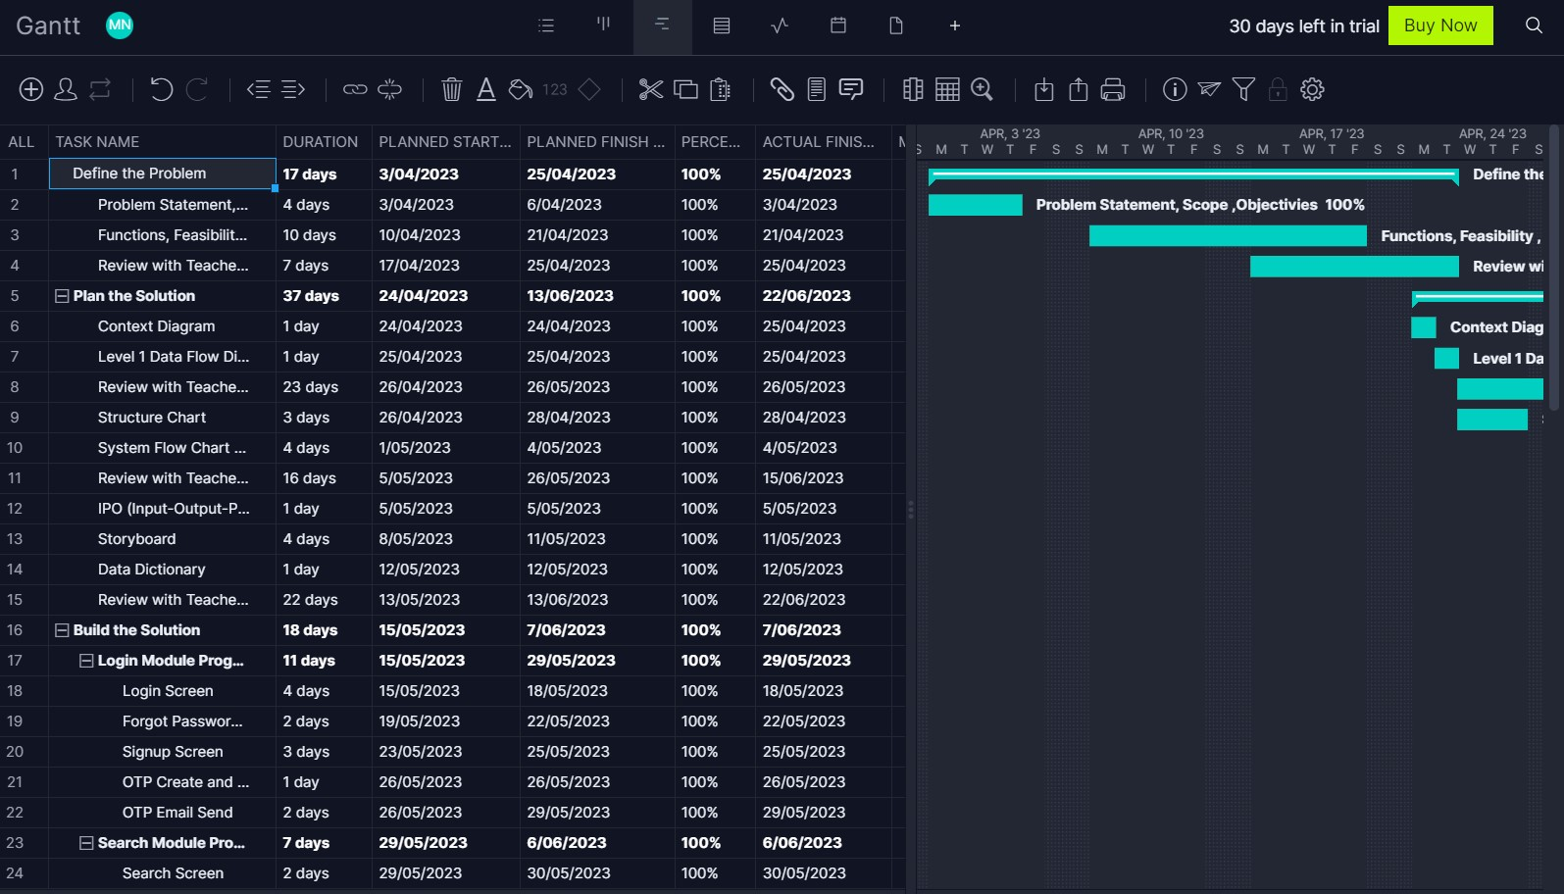

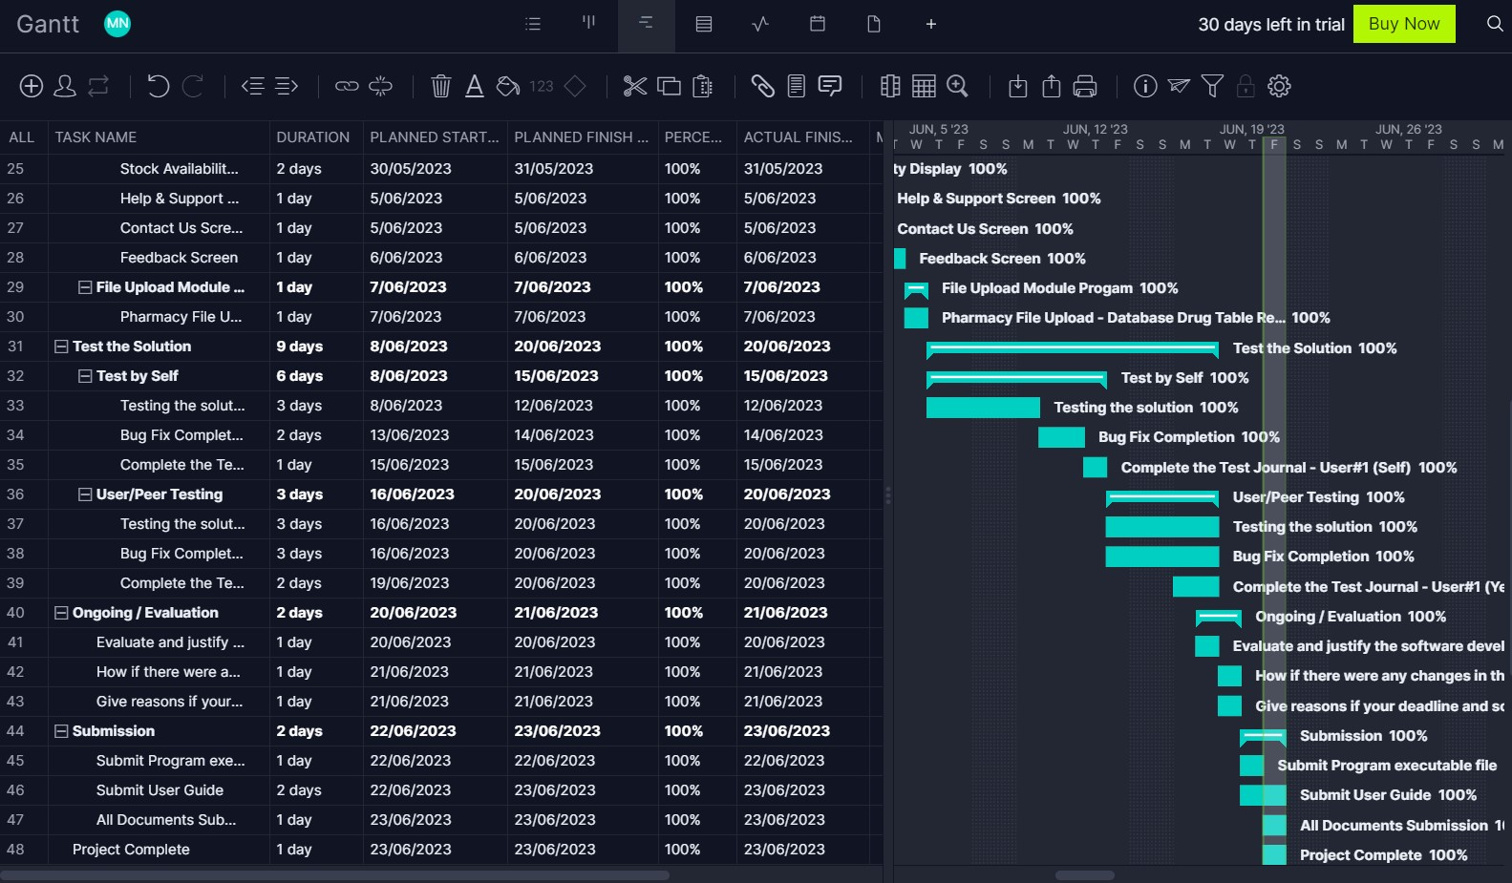

Defining the Problem

Problem Statement

Patients must physically visit many pharmacies to locate and purchase the essential medications, which causes difficulty and inefficiency. A software solution is required that makes it simple for patients to find and buy the necessary medications online by giving them access to real-time availability information and the contact information of the relevant pharmacy owners. The software intends to increase patient accessibility and convenience when buying medications, thereby enhancing their general health and wellbeing.

Low Level Problem Statement

Patients visit to various pharmacies to discover and buy necessary medicine, which is time-consuming and ineffective. To solve this problem, a software solution is necessary, allowing patients to easily discover the stock availability of medicine online. Real-time information on medicine availability and the names and contacts of pertinent pharmacy proprietors should be provided by the software.

Background

As individual patients need to go pharmacy store to get the medicines based on the prescription, if not available, they need to search in another store. This causes a lot of inconvenience for patients to get drugs on time. Sometimes this adds stress to their mind on top of what medical problems they are currently undergoing.

Hence the new online platform is required to connect all pharmacy providers in one place to manage the drugs demand from various patients, display stock availability in the App and establish online communication mechanism between patient and pharmacy to secure the drugs on time. The similar capability is currently available in the industry for ONLY healthcare providers and patients.
As I have got an opportunity to create an application as part HSC SDD project, I have chosen this initiative for my software development project.

Objective

The purpose of this project is to make all medicine data at one place to fulfill the medicine requirement for patient to search and get the desired outcome. It increases patient accessibility and convenience when buying medicine, thereby enhancing their general health and wellbeing.
The application is required for the pharmacy and patient to login with necessary verification, allow the pharmacist to upload medicine data and patient to search the data to understand the stock availability.

Scope

1.Let pharmacists log in: The software should let pharmacists access their portal and login to update the stock of medications in their respective stores.

2.Permit updating of availability: The software should enable pharmacists to update medication availability by posting daily updates on the status of medications in their individual pharmacies.

3.Storage and management of the data: The pharmacy-uploaded data should be stored and managed by the software in a database.

4.Patient login enabled: Patients should be able to enter onto their portal using the programme to look up specific medications.

5.Permit medication searching: By aggregating the daily updates from the pharmacists, the programme should allow users to search for certain medications and display the availability of the medication in various pharmacies.

6.Immediately the present search results: The software should provide the important information about the pharmacies, such as their contact data, without disclosing the pharmacist's name in a user-friendly manner.

7.Provide contact details of the pharmacist: Patients should be able to contact the pharmacist directly by using the software's contact information, which should include the pharmacist's email address.

8.Maintain records of searches and transactions: To make search tracking and monitoring simple and to guarantee that all searches and transactions are accurately recorded, the software should keep track of all searches and transactions.

Boundary / Out of Scope

- User authentication: The actual implementation of secure authentication mechanisms, such as encryption may be beyond the scope of this project for the authentication process.

- For new users to register and for logged-in users to enter, the project will offer signup and login options. The actual registration and login process, as well as any other specifications like connecting with external registration systems (sign up with Google, Apple), might be regarded as beyond the scope of the project.

- The project will build a search screen for users to conduct drug searches and display the availability of each medicine's stock. Real-time stock updates and actual integration with a drug database or inventory management system, however, can be viewed as outside the scope of the project.

- Establishing any online shopping between patient and pharmacy for medicine data.

- Detail data validation in medicine data file that will be uploaded by pharmacist.

Functionality

1.Create login screen GUI for patient and pharmacy to interact with Application
2. Provide an option for Signup for users to do registration if they are new to system
3. To avoid fraudulent or robot registration, the process should be available for user to do One time verification as part of Sign up
4. To help users, the Forgot password option is to be available with OTP verification, so that they can get their login information
5. Create a search screen for users (i.e., patient) to search the drugs, display the stock availability
6. Allow users to choose and then submit in search results, the communication mechanism should be established between patient and pharmacy.
5. Display the search results if the user inputted drug name matches. Otherwise display all the possible drugs that match some part of the name.
6. Create an automated process for pharmacies to upload their drug details into the App.

Feasibility

Technical Feasibility:
This application requires the software technical components to develop GUI (user front end) and data store (back end) for performing whole functionalities. The development can be done using Python Tkinter 3.10 for GUI and SQLlite3 for database operations. This application allows multiple concurrent user logins and database queries efficiently. The application requires the Laptop , 8.00 GB RAM, 11th Gen Intel(R) Core(TM) i5-1135G7 @ 2.40GHz 2.42 GHz , 64-bit Windows operating system V10 or 11. The PycharmProject Community Edition is an IDE environment where all Python and its package can be imported to develop the application. All these mentioned technical components come under Open Source software as voted by the Open Source Initiative (Source : https://www.python.org/doc/copyright/).
Financial Feasibility:
No software license and development cost is required because I have used Open Source software and my own study laptop to build this project. The purpose of this project is to produce MyPharmabank application as part of Year 12 SDD Project and not for commercial purposes.
Operational Feasibility:
The MyPharmabank application is developed as part of Year 12 SDD project to showcase my knowledge and not for commercial purposes. The workflow of patients and pharmacists would be improved if the application is used in their day-to -day operational purposes. This platform acts as a medium to help patients to get medicine on time and helps pharmacies to increase sales growth. No additional manual intervention required from pharmacies other than uploading the medicine data.
Legal and Regulatory Feasibility:
All the software technical components used to develop this application come under Open Source software as voted by the Open Source Initiative (Source : https://www.python.org/doc/copyright/)..The pharmacy or patient personal identifiable information is not published or shared in this application to ensure privacy standards are followed. This application is intended to show only the stock availability of medicine data to registered patients and definitely not for online purchase or sales transaction.
Schedule and Time Feasibility:
This project can be completed within the timeframe that has been set by the school teacher. I have planned my time efficiently to balance study time for other subjects and complete the development for SDD Project.

Plan the Solution

Context Diagram

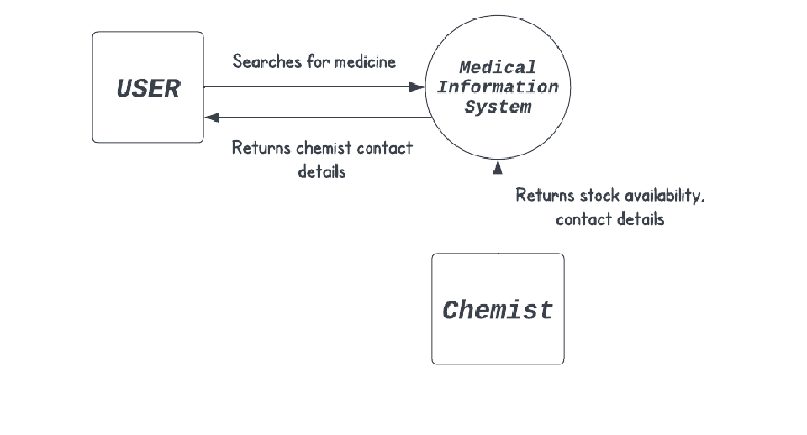

Level 1 Data Flow Diagram

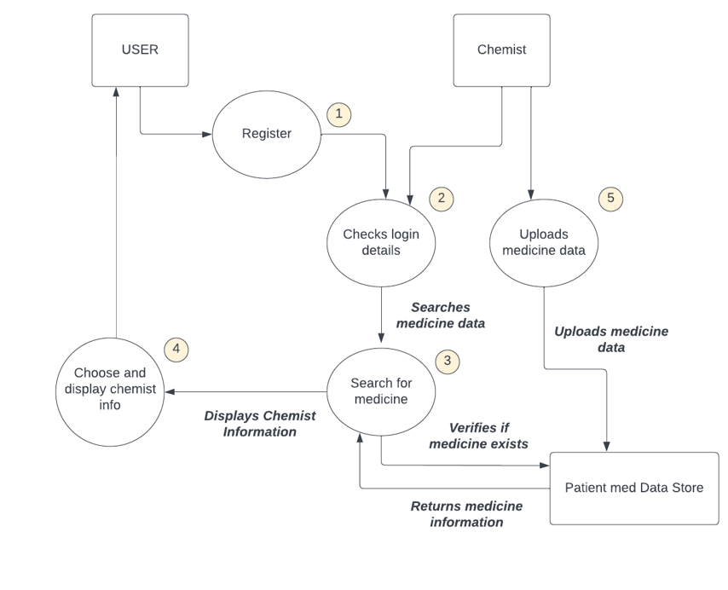

System Flow Chart (One Process – Registration)

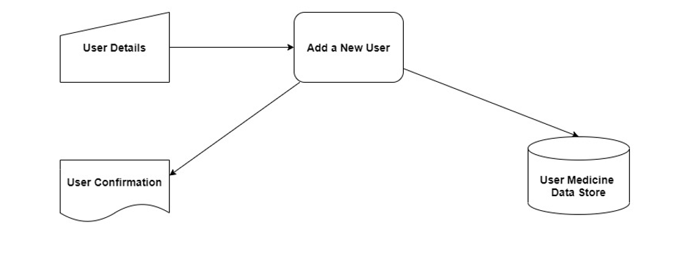

Structure Chart

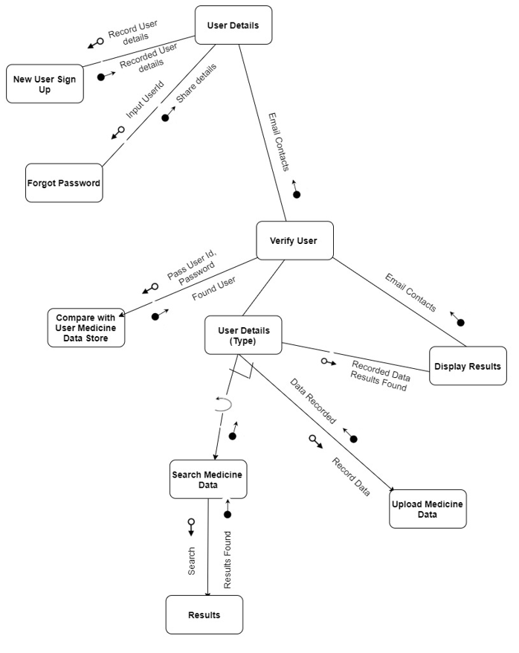

IPO Chart

Project : MyPharmabank Developer: Arjun Hariharasuthan
Subroutine Sequence#: 1
Subroutine Name : User Detail
Input | Processes | Output
On click “Register Button” | Redirect User to New User SignUp | New User SignUp Screen
User Id and Password , On click “Login Button” | Get User Id and Password and Pass to Verify Login and User Type
On click in Forgot Password Button | Redirect User To Forgot Password | Forgot Password Screen

Project : MyPharmabank Developer: Arjun Hariharasuthan
Subroutine Sequence#: 2
Subroutine Name : New User SignUp
Input | Processes | Output
Pharmacist and Patient Full Name, Password,  Email, Mobile, Patient Or Pharmacy, ABN, Unit & Street Number, Street Name, Suburb, Post Code, State | - Perform mandatory field value check.  - Password length check  - Email standard check  - ABN is mandatory if Pharmacy is chosen | Display the Successful message for Registration

Project : MyPharmabank Developer: Arjun Hariharasuthan
Subroutine Sequence#: 3
Subroutine Name : Verify User
Input | Processes | Output
Pharmacist / Patient User id , Password (from User Details ) | Pass the User Id and Password to Compare with Patient Medicine Data store
FoundUser (Receive from Compare with Patient Medicine Data store process) | Pass the FoundUser details to User Details(Type) | Email Contacts (Receive from Display Results Process)

Project : MyPharmabank Developer: Arjun Hariharasuthan
Subroutine Sequence#: 4
Subroutine Name : Compare with Patient Medicine Data store
Input | Processes | Output
Pharmacist and Patient User id , Password (from Verify User) | Read Login detail from Patient Medicine Data Store using User Id. | Send FoundUser and Type

Project : MyPharmabank Developer: Arjun Hariharasuthan
Subroutine Sequence#: 5
Subroutine Name : User Details(Type)
Input | Processes | Output
FoundUser & Type (Receive from Verify User Process) | Check If FoundUser is not empty and FoundUserType is either ‘I’ Or ‘B’ | If (I) Then Redirect To Search Medicine Data (Subroutine#5)  If (B) Then Redirect To Upload Medicine Data (Subroutine#7)

Project : MyPharmabank Developer: Arjun Hariharasuthan
Subroutine Sequence#: 6
Subroutine Name : Upload Medicine Data
Input | Processes | Output
CSV File , On click in Upload Button | Validate File is not empty.  Validate File contains fields are in correct order. | Data load to Patient Medicine Data Store.

Project : MyPharmabank Developer: Arjun Hariharasuthan
Subroutine Sequence#: 7
Subroutine Name : Search Medicine Data
Input | Processes | Output
Medicine Full Name or Medicine Short Name , On click in Search Button | Validate the Search input is not empty.  Get Medicine Full Name Or Medicine Short Name Pass it to Results process | Check and Confirm the Results Found

Project : MyPharmabank Developer: Arjun Hariharasuthan
Subroutine Sequence#: 8
Subroutine Name : Results
Input | Processes | Output
Search Medicine Full Name Or Medicine Short Name (Receive from Search Medicine Data) | Read Medicine details from Patient Medicine Data store using Medicine name. | Check and Confirm the Results Found

Project : MyPharmabank Developer: Arjun Hariharasuthan
Subroutine Sequence#: 9
Subroutine Name : Display Results
Input | Processes | Output
Check Recorded Data Results Found (Receive from Results Process) | Display the Data Results if available.  Display error message if not available. | Email Contacts

Project : MyPharmabank Developer: Arjun Hariharasuthan
Subroutine Sequence#: 10
Subroutine Name : Forgot Password
Input | Processes | Output
Email (UserId) | Perform OTP Authentication. | Share Login details in email

Data Dictionary

Table Name : REGISTRATION Primary Key : Email
Identifier | Data Type | No of Storage Bytes | Description | Example
Email | VARCHAR(100) | 200 | Email id of user which is used in registration. | Arjun1532006@gmail.com
Password | VARCHAR(20) | 40 | Password of user which is set in registration | 123456
Full_Name | VARCHAR(100) | 200 | Full name of user that includes First and Last name | Arjun Hariharasuthan
Mobile | SMALLINT | 1 | Mobile number of user which is used in registration. | 0491119850
Customer_Type | VARCHAR(1) | 2 | Type of user which could be I- Patient, B- Pharmacy | I
Pharmacy_ABN | VARCHAR(11) | 22 | Unique ABN (Australia Business Number) of Pharmacy. Not Applicable for Patient | 12345678911
Unit_Street_No | VARCHAR(10) | 20 | Unit and Street number of user contact address | 1/210
Street_Name | VARCHAR(50) | 100 | Street name of user contact address | Great Western Highway
Postcode | SMALLINT | 1 | Postal code of user of user contact address | 2145
Suburb | VARCHAR(50) | 100 | Unit and Street number of user contact address | Westmead
State | VARCHAR(3) | 6 | State short code of user contact address | NSW
Create_Datetime | TIMESTAMP | 7 | Data record created date and time | 2023-03-15 10:30:40
Table Name : MEDICINE_DETAIL
Identifier | Data Type | No of Storage Bytes | Description | Example
Pharmacy_ABN | VARCHAR(11) | 22 | Unique ABN (Australia Business Number) of Pharmacy. Not Applicable for Patient. | 12345678911
Pharmacy_Name | VARCHAR(100) | 200 | Full name of Pharmacy | Chemist Warehouse
Medicine_Full_Name | VARCHAR(150) | 300 | Full name of medicine that appears in the box | Nurofen Cold and Flu Multi-Symptom Relief Tablets 200mg Ibuprofen 24 pack
Availability_Quantity | SMALLINT | 1 | Total availability quantity of medicine | 12
Final_Price | DECIMAL(6,2) | 20 | Original price of medicine | 35.20
Discountted_Price | DECIMAL(6,2) | 10 | Discounted price of medicine | 30.20
Street_Name | VARCHAR(50) | 10 | Street name of pharmacy contact address | Campbell Street
Postcode | SMALLINT | 1 | Postal code of pharmacy contact address | 2150
Suburb | VARCHAR(50) | 100 | Unit and Street number of user contact address | Parramatta
State | VARCHAR(3) | 6 | State short code of user contact address | NSW
Upload_Datetime | VARCHAR(20) | 7 | Data record created date and time | 2023-03-15 10:30:40
Upload_By_Email | VARCHAR(50) | 200 | Email id of pharmacy which is used in registration. | chemist@gmail.com

Storyboards

The storyboard is split into two parts .The first part covers the login module, and second part covers the search or file upload and connected together with relevant symbol.
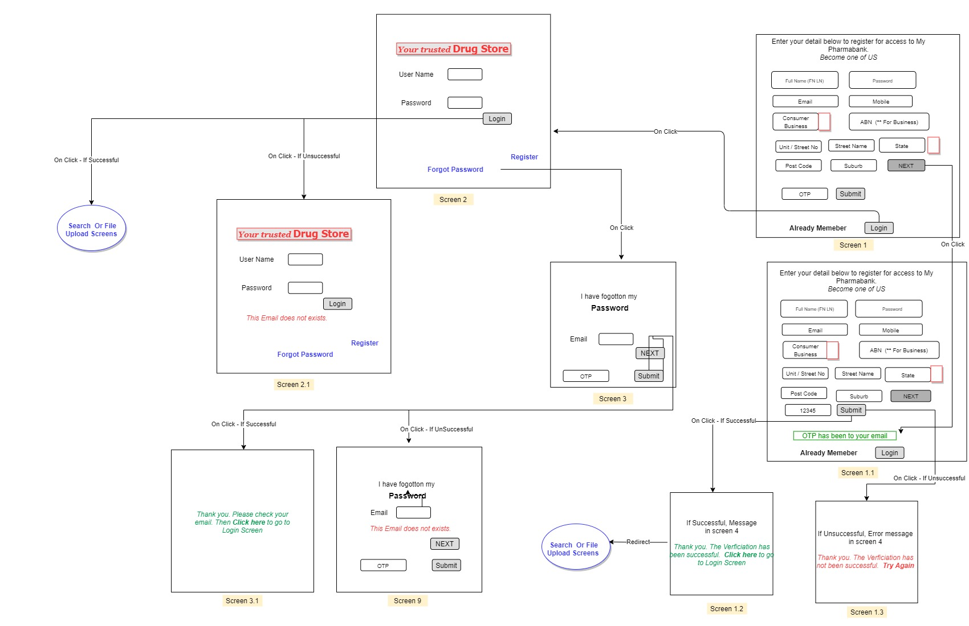

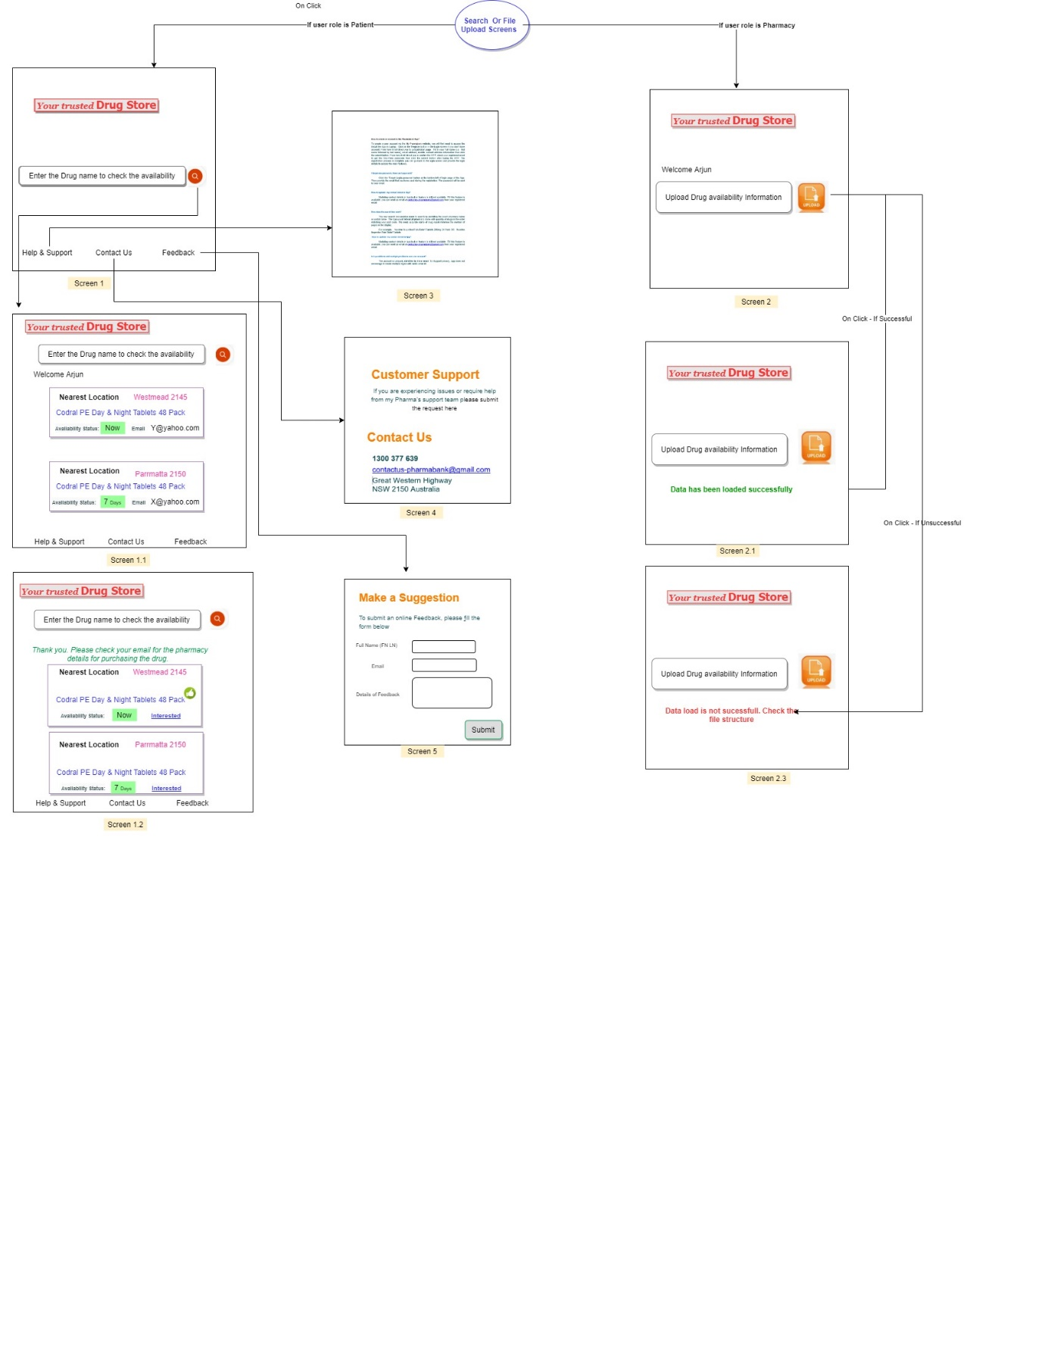

Test the Solution

Test Journal

The Test Journal describes the Peer Testing that is conducted 3 different level of peer groups with different age group to perform the testing. The Developer is expected to complete the unit testing is an initial step before proceeding into Peer Testing.

Peer Group #1 (Performed by Adult)
Test No | Test Issue Detail | Fix the Bug | Bug Fix Status | Code Version
1 | Sign up Screen - OTP is received. Contents of email is not detail enough | updated the contents | Done | Code V1.3
2 | File upload - Tried to upload incorrect file format with wrong sequence of fields. Page is not shown any error message | Provided error message for this scenario | Done | Code V1.4
3 | Alignment of contents are not ok in support pages - help and support | Updated the font to all contents | Done | Code V1.3
4 | Forgot password - OTP should be there. Otherwise, everyone misuses it | Added OTP check | Done | Code V1.3
5 | Display street no and street name of pharmacy | Can not be done due to privacy reason | Done | Code V1.3
6 | Sign up Screen - multiple logins are created with same email | Added check if same email is used more than once | Done | Code V1.4
7 | If load incorrect files (incorrect no of header columns), I am not getting any response | Added validation to show the incorrect file is supplied | Done | Code V1.4
8 | Contact us - Alignment is not proper | I have changed the position to look better | Done | Code V1.5
9 | Term of Use is missing | Added in the Sign-up Scree | Done | Code V1.6
10 | After Log in, It would be good if the screen is displayed with user name | This is not part of original scope. Will include it and fix if I have time | Done. But Scope Variation | Code V1.7
11 | Is it possible to connect myself and pharmacy over the email instead of only displaying the email in search screen | This is not part of original scope. Will include it and fix them in the future version | Scope Variation - Not Complete
12 | The disclaimer is supposed to be added | The disclaimer was essential to inform the users that we are just a medium and we do not take any responsibility for any loss. | Done | Code V1.8
13 | The font size of the title was too small compared to the others | I made sure the title was a little bigger compared to the others so it large enough to draw the users eyes. | Done | Code V1.8

Peer Group #2 (Performed by Year 12 School Student)

Test No | Test Issue Detail | Fix the Bug | Bug Fix Status | Code Version
1 | Background is not consistent in Search screen | Fixed all screens with similar background | Done | Code V1.1
2 | After I enter same email id for registration, I get error "email already used for registration". But OTP is still coming | Added check before OTP email send | Done | Code V1.1
3 | Sign up screen - Keep same interval between entry | Aligned | Done | Code V1.1
4 | I have not received OTP . | This is due to firewall or network restriction issue in School Wi-Fi. The OTP is sent from Gmail. The Gmail login is blocked in school Wi fi. If you change it to personal Wi-Fi , You will get the OTP. | After User tried with Personal Hotspot, He has received OTP. | Code V1.2

Peer Group #3 (Performed by Adult)

Test No | Test Issue Detail | Fix the Bug | Bug Fix Status | Code Version
1 | I don’t know how to use this app | Explained him how to use this | Done | Code V1.2
2 | File upload screen is not coming if I register as pharmacist | Added condition in login and sign-up screen if pharmacist login then go to file upload screen | Done | Code V1.2
3 | I registered as I, but it is taking me to file upload page | The variable used incorrectly to check the condition. I have fixed it | Done | Code V1.2
4 | sometime search results are not consistently aligned | I have fixed it by adjusting x and y position | Done | Code V1.2
5 | back button position is not properly fixed in search page | I have changed the position to look better | Done | Code V1.2
6 | Check spelling in Help and Support | I have validated the contents | Done | Code V1.2

Ongoing / Evaluation

Evaluate Software Development Approach

The Structured or Waterfall software development approach is used to build this project. As this approach enforces that the next phase is not started until the previous phase is completed, which helped me to discuss my requirement ideas with the teacher upfront and to create and review the entire project scope , plan and design with the reviewer. For my SDD year 12 major project, I created this application which acts as a medium for patient to search and understand the stock availability of medicine data which comes from various pharmacists.

While creating this application, I’ve gone through all stages (starting from defining the problem, Plan the solution, Build the solution, Test and Evaluate). The way I utilized this approach was for example, I wanted to create all the design diagrams for planning the solution before building the solution successfully without major rework. Hence, it is important to follow all of them in order, so it doesn’t get collapsed in the end.

What if there were any changes in the development steps after customer and peer feedback

Yes, there were changes to the development after the customer and peer feedback.
I have approached school mates who told me that the program's GUI design needed some improvement to attract users and suggested that it could look much better if I focus on my aesthetics for the GUI. So, I gave it some more time, and made GUI designs from Canva. The same school mate felt awesome after seeing the updated version. I have tried it with my parents, and they felt like the font could be a little larger , with colour highlights on key messages. so, it was easier for them to read it nicely.

Give reasons if your deadline and scope has changed in any way this includes any changes of the number of man hours calculated in your Gantt Chart?

My schedule for planning the solution was changed than expected as it required regular check-ups with reviewer (Mr.Phua), and it took more iterations to review my Context & data flow chart and to get the approval. Since all the other diagrams are dependent on the DFD, it all got a little delayed. But it was adjusted in development time. I was able to complete my development quickly as I understood very well from planning the solution stage itself.

Submission

User Manual

About the User Manual

This user manual is intended to provide an assistance to use on this App (Application). This is the step-by-step instructions on how to setup, run and interact with computer. Also, it covers the minimum hardware and software requirements to utilise the application effectively. In case of any difficulties in using the App (say error arise), The troubleshooting methods describes the various problem and assistance with solution to fix them.

Synopsis

As individual patient needs to go pharmacy store to get the medicines based on the prescription, if not available, they need to search in another store. This causes a lot of inconvenience for patients to get drugs on time. Sometimes this adds stress to their mind on top of what medical problems they are currently undergoing.
Hence the new online platform is required to connect all pharmacy providers in one place to manage the drugs demand from various patients, display stock availability in the App and establish online communication mechanism between patient and pharmacy to secure the drugs on time. The similar capability is currently available in the industry for ONLY healthcare providers and patients.
The core functionality is summarised as

1.Create login screen GUI for patient and pharmacy to interact via Application
2. Signup option for users to do registration if they are new to system.
3. To avoid fraudulent or robot registration, the Signup process is enabled with One time verification.
4. Forgot password option is available with OTP verification to meet security requirements.
5. Search screen for users (i.e., patient) to display the stock availability and contact information of pharmacy.
6. File upload process for users(i.e Pharmacy) to upload their drug details into the Application.

Minimum Specifications (Software and Hardware):

Hardware
Hardware | Windows
Processor | Intel Core i3 6300  
RAM | 4 gigabytes (4GB)
Memory | 64 gigabytes (64 GB)  64 gigabytes (128 GB)

Software
Operating Systems | Windows 10 or 11.
Programming Languages | Python V3.10
Database | SQLite 3
GUI | Python Tkinter
Packages Required to Support | from tkinter import *  import ttkbootstrap as ttk  from subprocess import call  import sqlite3  import re  from tkinter import messagebox  import json  from tkinter import filedialog  import csv  from datetime import datetime  import os  from email.message import EmailMessage  import ssl  import smtplib  import secrets  import string  import time  import customtkinter

Setup Application

For devices with Windows 8.1 or newer:

- Download the ‘Mypharmabank.zip’ file.
- Locate the downloaded zip in your downloads folder and if necessary, you can simply move it to any other comfortable location of your choice by simply CTRL X + CTRL V in any location like the desktop.
- Double-click on the zip file. You should be able to access the contents of it. If double-clicking on it doesn’t work, then right-click on the file, and select the option ‘Extract All’.

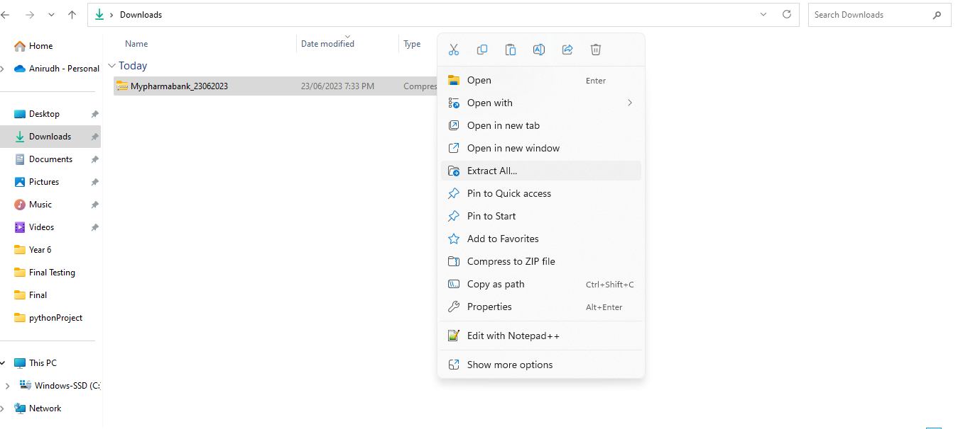

A small box will appear asking you to type a directory in which the extracted folder is going to be stored. Simply click the ‘browse’ button and choose a suitable location.

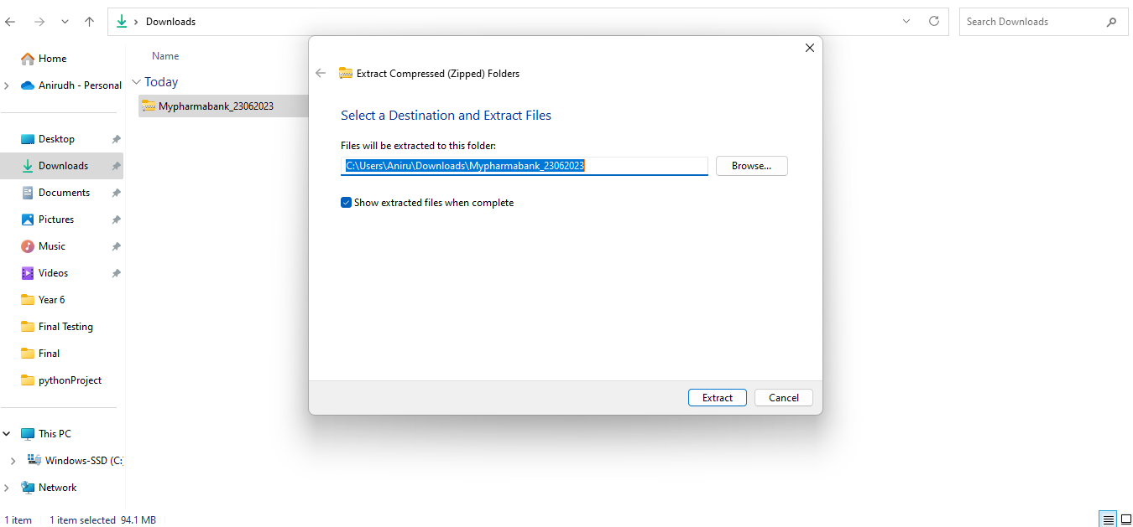

- Once you double-click the folder, you’ll be brought to a screen looking like this. Here, press the ‘Mypharmabank’ folder.

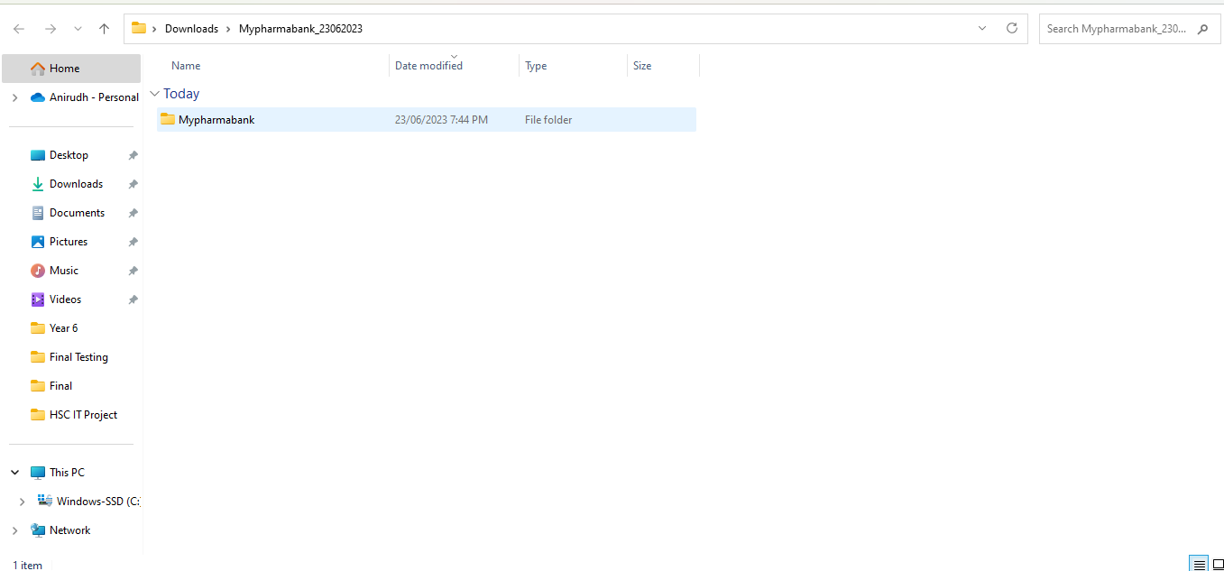

- Open the “Mypharmabank” Folder, you can find the application name “MyPharmabank” and click on it

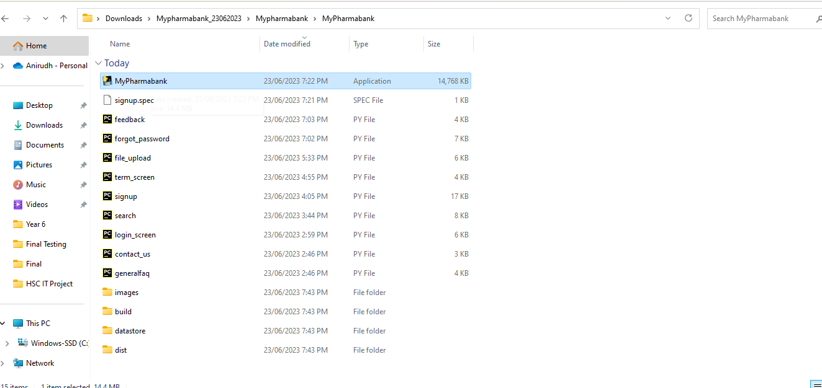

- The final step! Please double click the MyPharmabank” application to view GUI sign up screen.

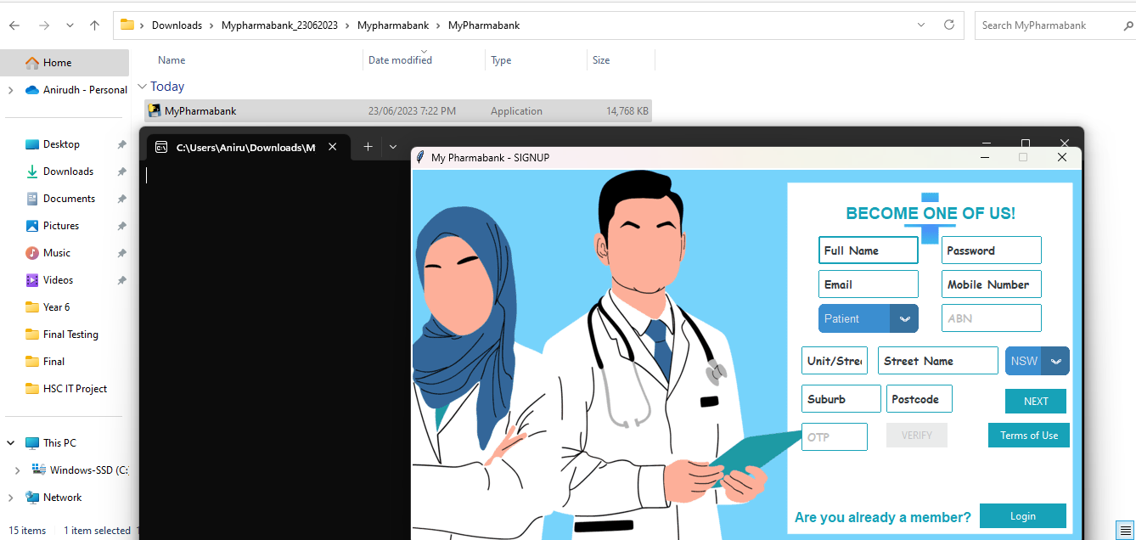

How to Use Mypharmabank

Signup Screen

After clicking the ‘Sign up’, The registration screen is displayed to collect all your information. Once you have inputted the required information in the given textboxes, then choose ‘Patient’ from Dropdown box click ‘NEXT’ button. If you don’t enter the mandatory information the application will be displayed with error message on which fields are to be entered.

Sign up As Patient
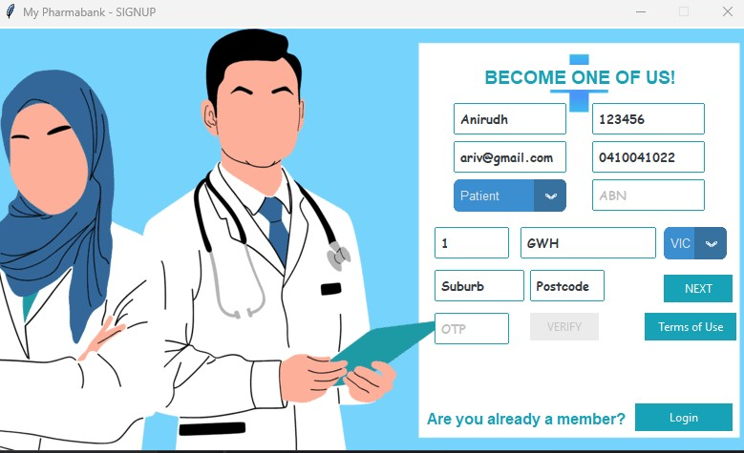

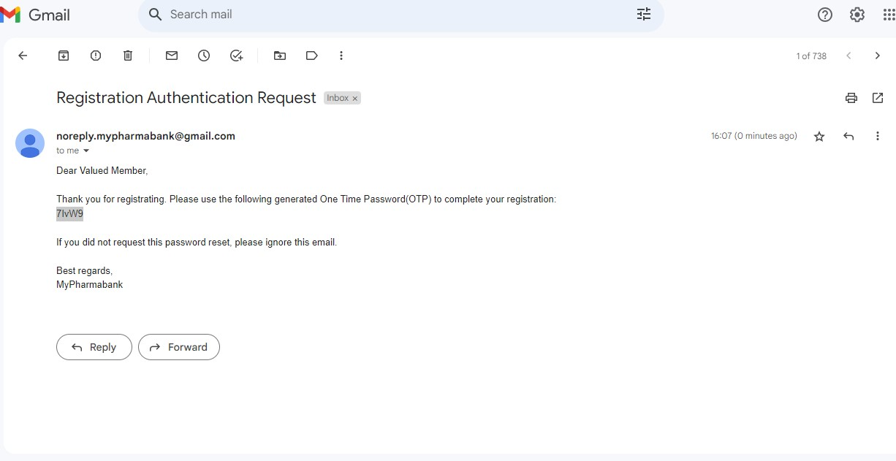
Signup Screen – Before OTP
After providing all the details, The One Time Verification code will be sent to registered email. Then provide “OTP” number and click ‘VERIFY’ button to complete the registration. After displaying registration successful message, it will redirect you to “Search” page in few seconds if you have registered as ‘PATIENT’. Note - In case of any difficulties for not receiving OTP, please check your spam folder.

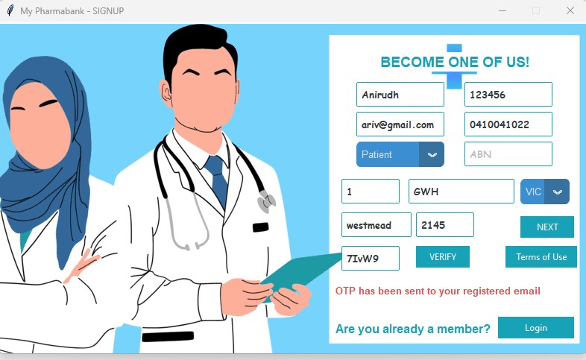
Signup Screen – After OTP

Sign up As Pharmacy
After clicking the ‘Sign up’ from the login screen, The registration screen is displayed to collect all your information. Once you have inputted the required information in the given textboxes, then chosen ‘Pharmacy’ as Customer Type Dropdown box click ‘’ button. If you don’t enter the mandatory information the application will be displayed with error message on which fields are to be entered
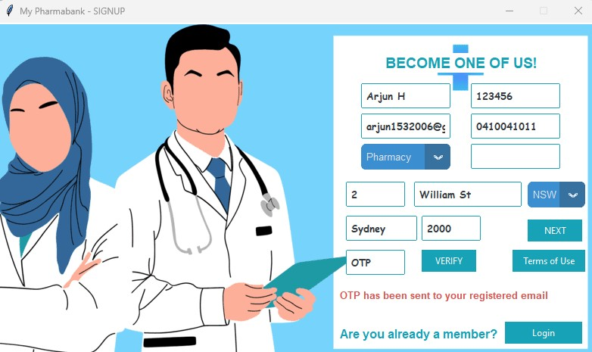
Signup Screen – Before OTP
After providing all the details, The One Time Verification code will be sent to registered email. Then provide “OTP” number and click ‘’ button to complete the registration. After displaying registration successful message, it will redirect you to “File Upload” page in few seconds if you have registered as ‘PHARMACY’. Note - In case of any difficulties for not receiving OTP, please check your spam folder.

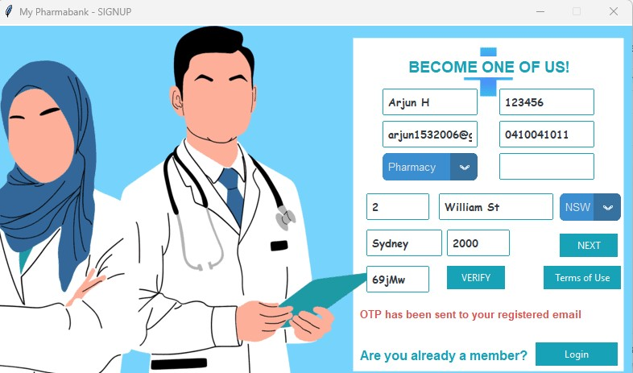

Signup Screen – After OTP
Search Medicine Screen

You can provide the medicine full name If known (e.g Nurofen Cold and Flu Multi-Symptom Relief Tablets 200mg Ibuprofen 24 pack). It would display the pharmacy details with contact information and stock availability. If you decide to quit the Application, click the ‘X’ windows exit button.

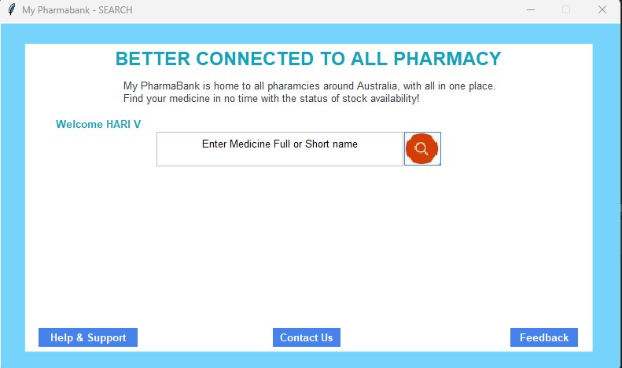

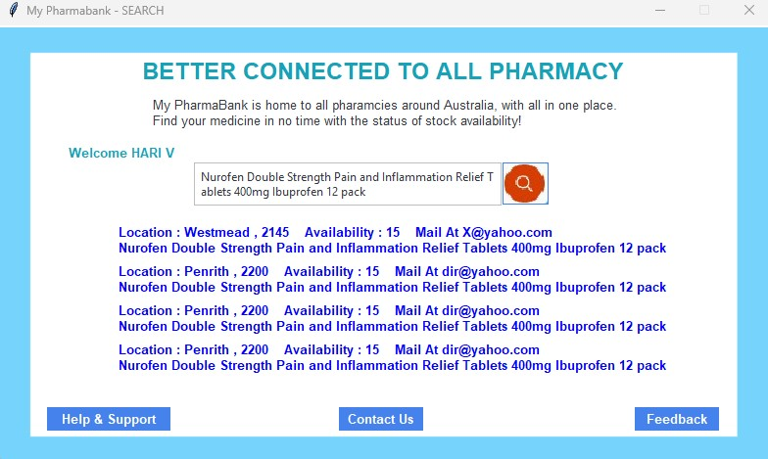

Search Screen – Search Input Option 1

You can also provide the medicine short name If full name is unknown (e.g Nurofen). It would display the pharmacy details with contact information and stock availability. If you decide to quit the Application, click the ‘X’ windows exit button.

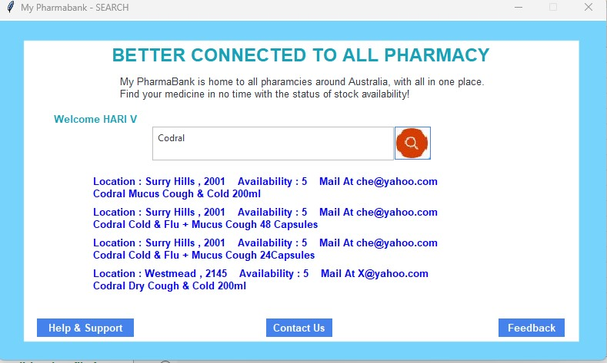
Search Screen – Search Input Option 2

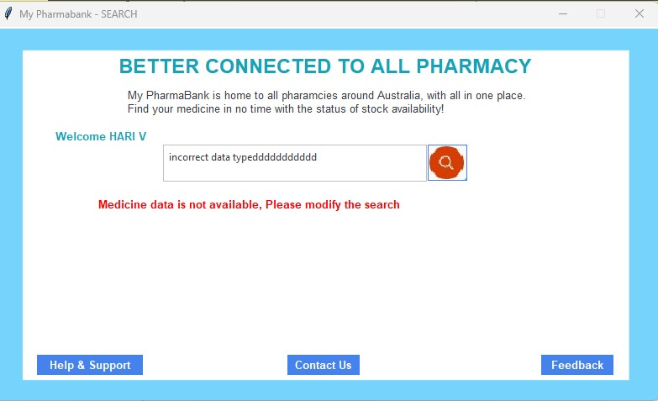
Search Screen – Search Input Option 3 (Incorrect Value)

File Upload Screen
The File upload screen allows to upload the .csv file which contains the medicine stock, pharmacy and its contact details with comma separated file. The fields sequence needs to be followed as per below information. If it is not, the application will be displayed with error message on which fields are to be entered.
The Fields sequence in the file is shown as below.

Sample Correct file format is attached below.
Sample Incorrect Data file is attached below

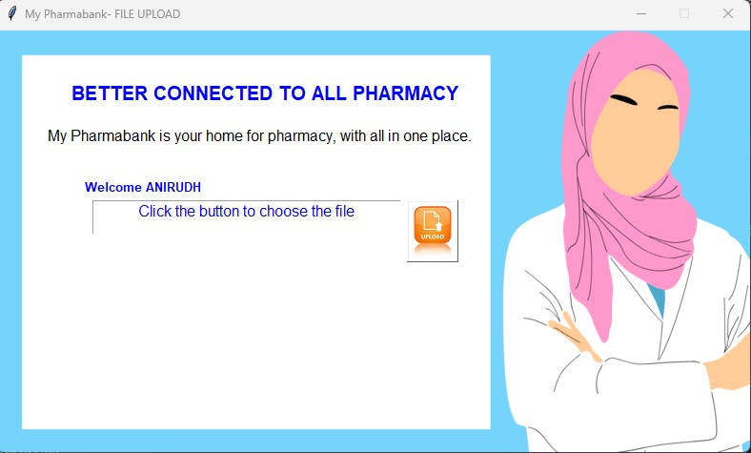
File Upload Screen – Before Uploading
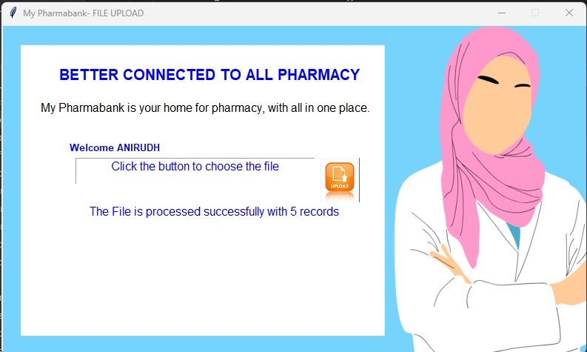
File Upload Screen – After Uploading

Login Screen

Once you have opened the program, click the ‘Sign up’ to complete the registration. If you already have the login details, provide and click ‘Submit’ button. If you already have the login details, but forgot the password, click ‘Forgot Password’ button. If you decide to quit the Application, click the ‘QUIT’ button.

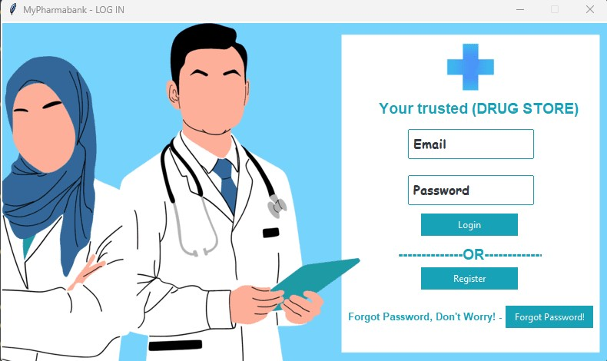

Login Screen

Forgot Password Screen
After clicking the ‘Forgot Password’ from the login screen, The forgot password screen would ask you to enter registered email address in the entry text box. Then click ‘Submit’ button.

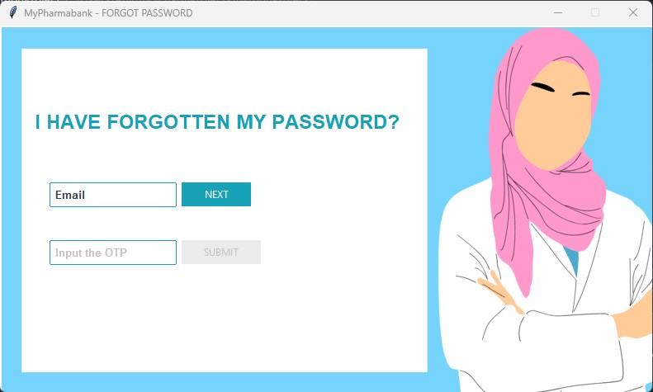

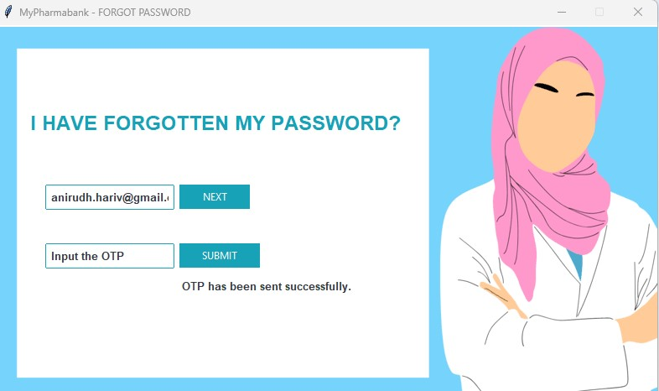

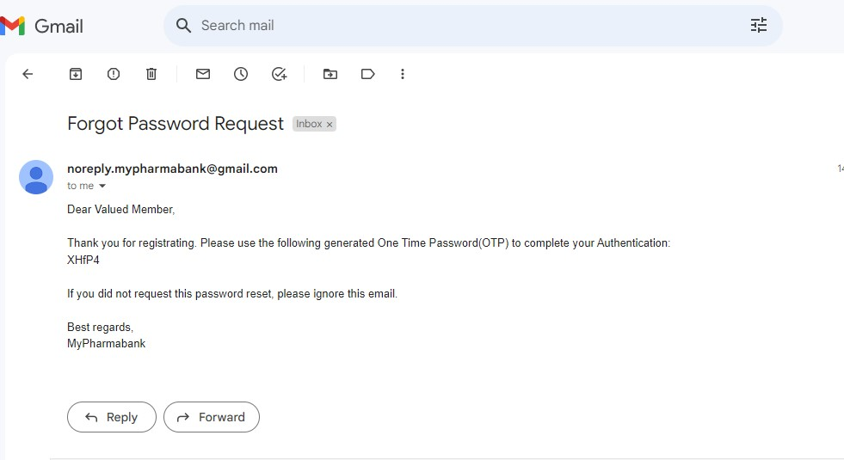

Forgot Password Screen -Before OTP

The One Time Verification code will be sent to registered email. Then provide “OTP” number and click ‘’ button to receive the password in the registered email.

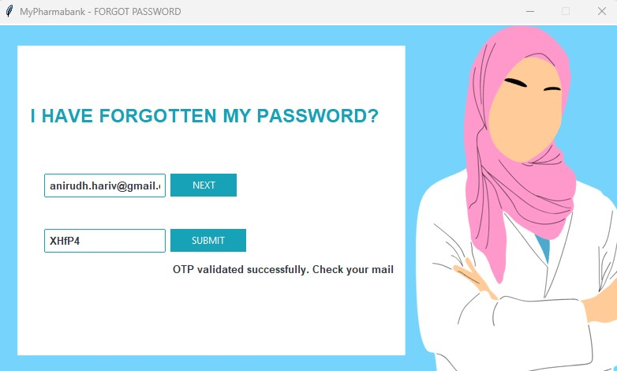

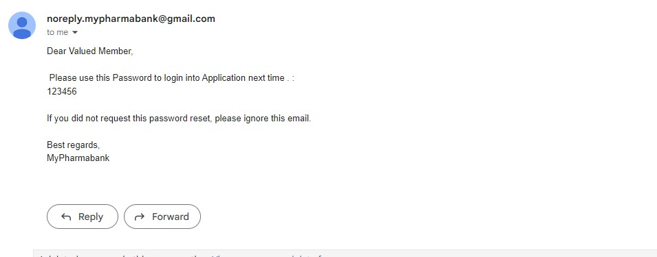

Forgot Password Screen -After OTP
Feedback Screen

The Feedback screen allows the user to enter detail of issue with their contact details. This helps Application owner to enhance the functionalities and gaps in the subsequent Application development.

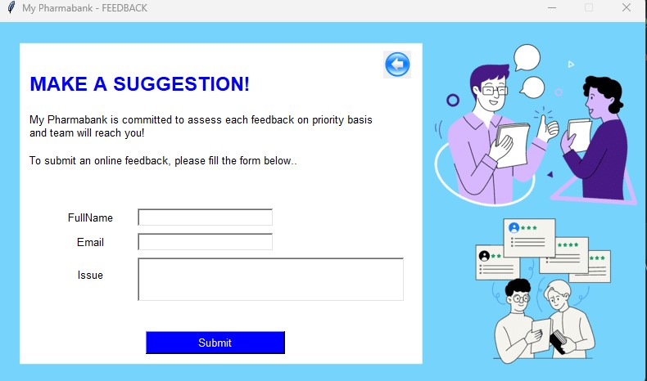

Feedback Screen

Help & Support Screen

The Help & Support screen is static page that provides information about how this application should be used functionally.

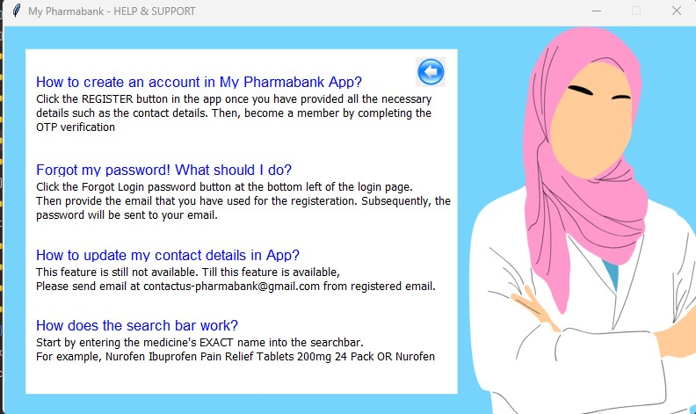

Help & Support Screen

Contact Us

The Contact Us screen is static page that provides contact information about the owner of application in case of any issues or communication.

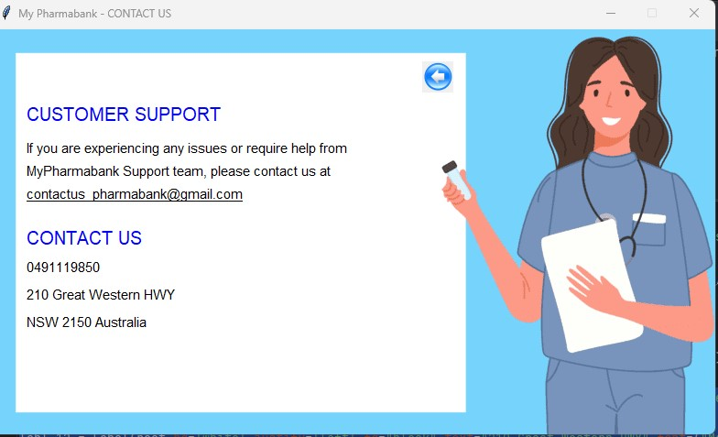

Contact Us Screen -After OTP

Troubleshooting

1. Why am I unable to open the zip file on Windows?
There could be multiple reasons.

- Compression: The file compression may have not worked as it was not compatible. For such case, try reliable tools like WinRAR and WinZip for efficient compression. The download links are provided below
WinRAR: https://www.win-rar.com/
WinZip: https://www.winzip.com/en/

- Virus: In all laptops, downloading an .exe file from the internet or any other source is considered dangerous and as such, the computer may think it contains a virus. In this case, make sure anti-virus software is enabled like Windows defender Or Norton Security or McAfee reduces the chances of a virus occurring.
- Crashes: In the case where your system just crashes during download, restart your computer, and re-download the zip file. This should give your computer some time to recover from stress.

2. What if user has not received an OTP?
- Please ask user to check the email that comes from noreply.mypharmabank@gmail.com

- Or search the email in Spam folder and move it to Inbox once found.

- If WIFI is in restricted environments , that might block the email as it is coming from GMAIL. For example, The OTP email has not gone to user in School Wi-Fi as it restricts the use of GMAIL in school premises.
3. How to handle if OTP process fails due to “File already exists with same name”?
The OTP process creates a temporary txt file in the computer with name of registered email.txt. It deletes the file after successful verification. Sometimes if it is not deleted, please delete them as part of clean-up process then OTP process works smoothly.

4. What if the error “Database table is locked”?
You would get this error very occasionally. This could be the application is already opened by you for processing, again you are trying to open the Application for other functionality. If it happens, please close one of application using window X exit button.

Frequently asked questions

What language was used?
We primarily used Python & Tkinter as GUI as our language of choice with several imported modules giving us the freedom to create such a powerful piece of software.

Why can’t I maximise the screen?
For the application’s inner buttons and labels to not lose their positioning, maximising has been locked. In case of any inconvenience, We apologies and are working on fixing it in the next version update

What software development methodology has been used?
This application was developed using an Waterfall methodology.

Is the program easily executable by anyone?
Anyone has good knowledge on windows platform, they can run it easily. If more help is needed, refer to the previous pages or contact us directly.

For any further queries, please feel free to contact us at:
noreply.mypharmabank@gmail.com

References

Software Development Approach | Software Design and Development by Samuel Davis
Database – SQLite | https://www.sqlite.org/index.html
Programming in Python | https://pythonguides.com/
Gantt Chart | Project Manager Software Evaluation Version

